
EAST WEST UNIVERSITY

Department of Computer Science and Engineering

Project Report

Submitted to:

- Syed Jamiul Alam

- Lecturer

- Department of Computer Science and Engineering

- East West University

Submitted by:
Group members | Sumaiya Akter | 2023-3-60-579
 | Anjuman Ara | 2024-1-60-279
 | Rakib Al Hasan | 2024-1-60-143
Group | 09
Course Title | Electronic Circuits
Course Code | CSE 251
Section | 11
Semester | Fall 2025
Date of Submission | 18.12.2025


EAST WEST UNIVERSITY

Department of Computer Science and Engineering

Project-01: The Simplest BJT Amplifier
1. Objective
The objective of this project is to design, simulate, and implement a simple common-emitter BJT amplifier using collector-to-base feedback. The amplifier must provide a minimum voltage gain of 2, improved bias stability, and operate correctly with a 1 kHz sinusoidal input signal. The design is verified through LTspice simulation and practical breadboard implementation, followed by oscilloscope measurements.

2. Theory of Operation
A common-emitter (CE) amplifier provides high voltage gain with a 180° phase inversion between input and output. In this project, a collector feedback resistor (Rf) is used instead of a traditional voltage-divider bias.
Collector Feedback Biasing
- The feedback resistor connects the collector to the base.
- Any increase in collector current reduces the collector voltage.
- This reduction feeds back to the base, lowering base current.
- As a result, the Q-point becomes more stable against temperature and transistor beta (β) variations.
This configuration is simpler and more stable than fixed-bias amplifiers, making it suitable for introductory analog electronics projects.

3. Circuit Description
The designed amplifier uses an NPN transistor (2N3904) in a common-emitter configuration.
Main Components and Values
Component | Value | Description
Q1 | 2N3904 | NPN BJT
VCC | 12 V | DC supply voltage
RC | 2.2 kΩ | Collector resistor
RE | 1 kΩ | Emitter resistor
Rf | 470 kΩ | Collector-to-base feedback resistor
Cin | 1 µF | Input coupling capacitor
C1 | 10 µF | Output coupling capacitor
RL | 10 kΩ | Load resistor
Vin | SINE(0, 0.5 V, 1 kHz) | Input signal
Working Principle
- The input AC signal is coupled to the base through Cin, blocking DC.
- The transistor amplifies the signal in the active region.
- RC converts collector current variations into output voltage.
- RE provides emitter degeneration, improving linearity and stability.
- Rf provides negative feedback, stabilizing the operating point.
- The amplified signal is taken from the collector via C1 to the load.

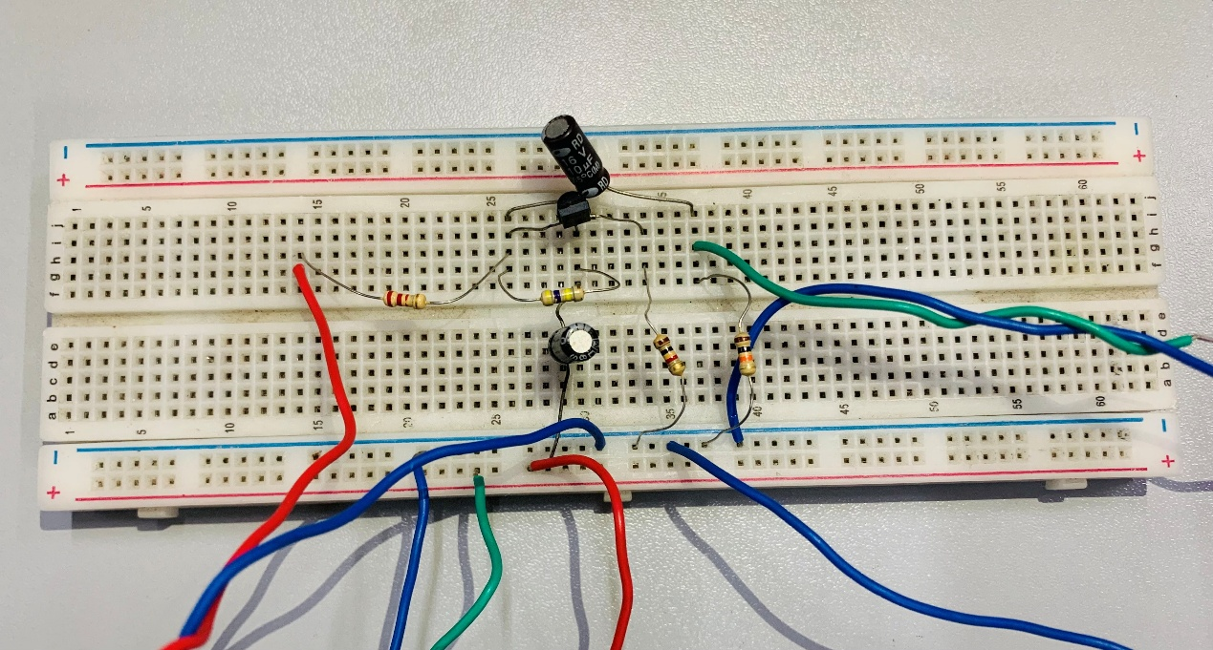

Circuit Diagram

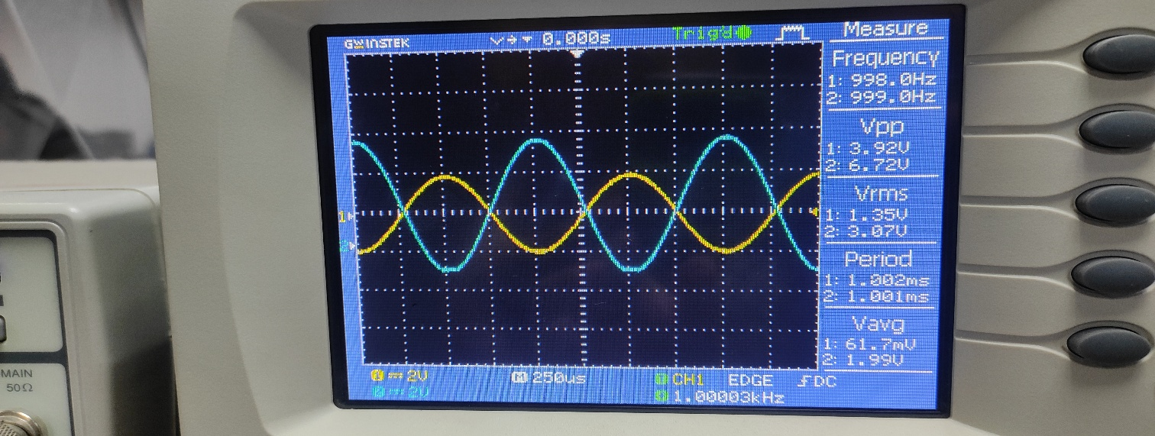

Simulation Result

4. Simulation Using LTspice
The circuit was simulated in LTspice using transient analysis.
Simulation Settings
- Supply Voltage: 12 V
- Input Signal: 0.5 V (peak), 1 kHz sine wave
- Simulation Command: .tran 0 5m
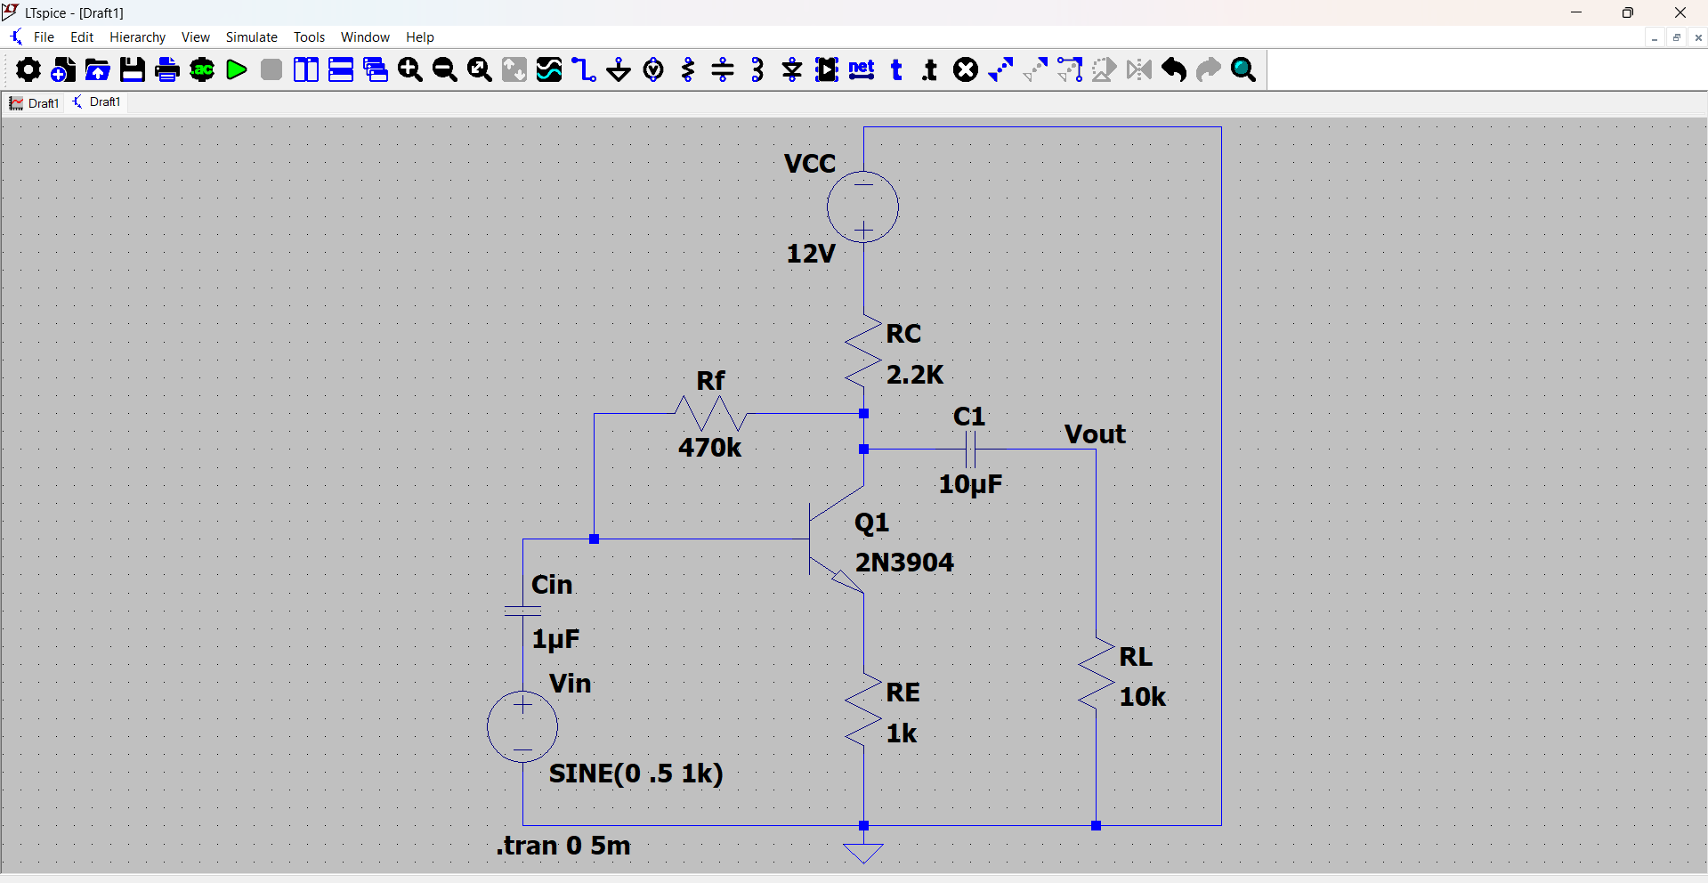

Circuit Diagram
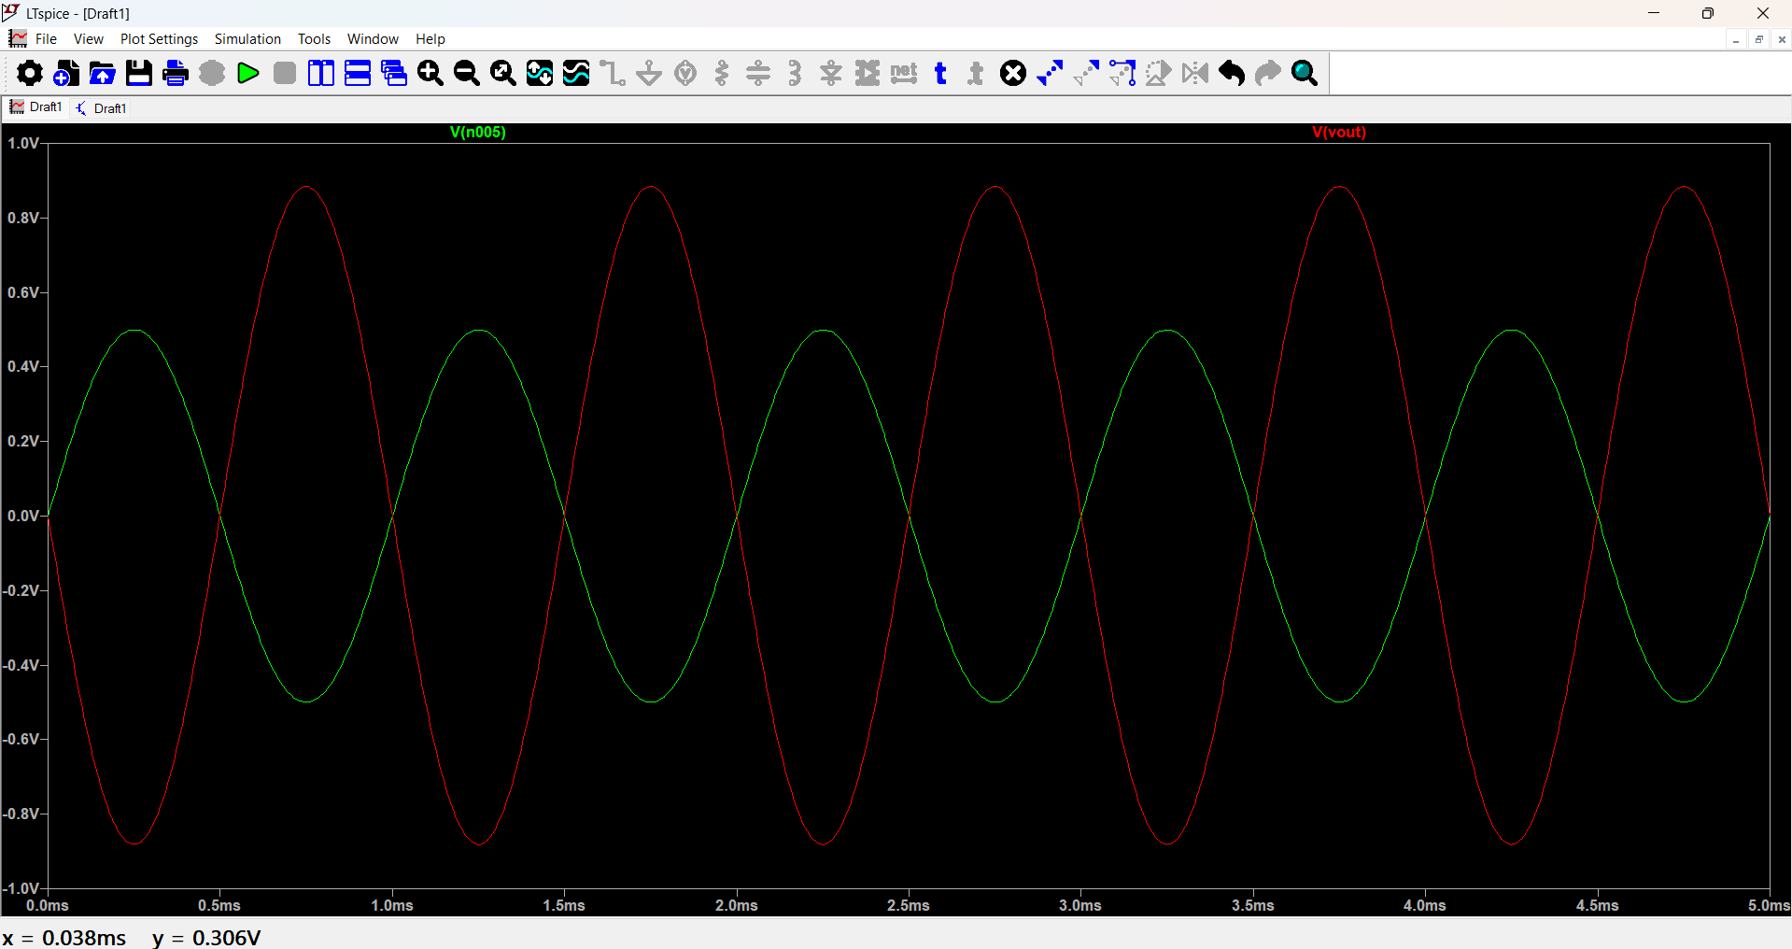

Simulation Result
Simulation Results
- Input peak voltage ≈ 0.5 V
- Output peak voltage ≈ 0.9 V
- Voltage Gain (Av):$$Av=\frac{Vout}{Vin}=\frac{0.9}{0.5}=1.8≈2$$
- Output waveform is inverted (180° phase shift), confirming common-emitter operation.
- No noticeable distortion, indicating proper biasing in the active region.

5. Practical Implementation
The circuit was assembled on a solderless breadboard using the same component values as the simulation.
Experimental Setup
- Function Generator: 1 kHz sine wave
- Oscilloscope: Dual-channel (input and output observation)
- Power Supply: 12 V DC
Observations from Oscilloscope
- Channel 1 (Input): ~3.92 Vpp
- Channel 2 (Output): ~6.72 Vpp
Measured Voltage Gain
$$Av=\frac{Vout}{Vin}=\frac{6.72}{3.92}=1.7≈2$$
The practical gain is slightly lower than the simulated value due to:
- Transistor parameter variations
- Breadboard losses
- Loading effects
Despite this, the amplifier successfully meets the minimum gain requirement and shows stable operation.

6. Comparison Between Simulation and Practical Results
Parameter | Simulation | Practical
Input Frequency | 1 kHz | 1 kHz
Voltage Gain | ≈ 2.0 | ≈ 1.7
Phase Shift | 180° | 180°
Stability | High | High

The results confirm good agreement between theory, simulation, and hardware.

7. Advantages of Collector Feedback Amplifier
- Simple biasing network
- Improved thermal stability
- Reduced sensitivity to β variations
- Suitable for low-frequency signal amplification

8. Limitations
- Lower voltage gain compared to multi-stage amplifiers
- Gain affected by emitter resistor and feedback
- Not suitable for high-frequency applications

8A. Hand Calculations: Q-Point & Gain Derivation
8A.1 DC Analysis and Q-Point Calculation
For DC analysis, coupling capacitors Cin and C1 act as open circuits.
Given:
- VCC = 12 V
- RC = 2.2 kΩ
- RE = 1 kΩ
- Rf = 470 kΩ
- VBE ≈ 0.7 V
- β ≈ 100

Approximate base current due to collector feedback:
IB = (VC − VBE) / Rf
Emitter current:
IE ≈ (β + 1) IB ≈ IC
Emitter voltage:
VE = IE × RE
Base voltage:
VB = VE + 0.7 V
Collector voltage:
VC = VCC − IC × RC
Solving iteratively using typical values:
- IC ≈ 2.5 mA
- VE ≈ 2.5 V
- VB ≈ 3.2 V
- VC ≈ 6.5 V
Hence, the Q-point is:
IC ≈ 2.5 mA, VCE ≈ 4.0 V
This Q-point lies well inside the active region, enabling undistorted amplification.

8A.2 Small-Signal Voltage Gain Calculation
The approximate voltage gain for a CE amplifier with emitter degeneration is:
Av = − (RC || RL) / (re + RE)
Where:
re = 26 mV / IE
re = 26 mV / 2.5 mA ≈ 10.4 Ω
Effective collector load:
RC || RL ≈ (2.2 kΩ × 10 kΩ) / (2.2 kΩ + 10 kΩ) ≈ 1.8 kΩ
Voltage gain:
Av ≈ −1800 / 1010 ≈ −1.78

8A.3 Interpretation
- Negative sign indicates 180° phase inversion
- Gain magnitude > 1.7 satisfies project requirement
- Calculated gain closely matches simulation and experimental values

9. Conclusion
A simple common-emitter BJT amplifier using collector-to-base feedback was successfully designed, simulated, and implemented. The amplifier achieved a voltage gain close to 2, operated stably at 1 kHz, and demonstrated good agreement between simulation and experimental results. This project confirms the effectiveness of collector feedback biasing for simple and stable amplifier designs.

10. References
- Sedra & Smith, Microelectronic Circuits
- Boylestad & Nashelsky, Electronic Devices and Circuit Theory
- LTspice Documentation

